Name: Ali Albayrak

Student ID: P304320

Static Analysis Tool

To use a tool for php, we have to set and install it from cmd.

Open cmd with admin rights and go to php directory;

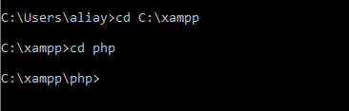

After that we should command to install Php Code_Sniffer;

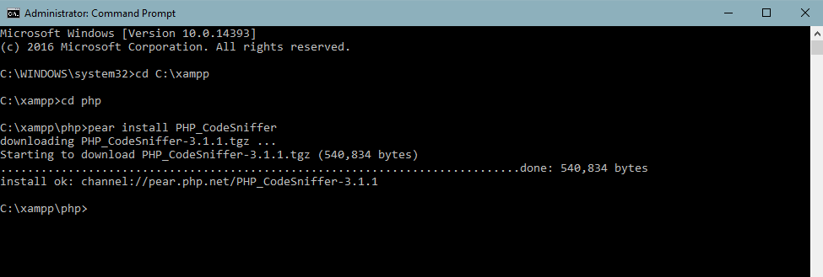

To use the tool we downloaded, we should simply specify the file`s location.

